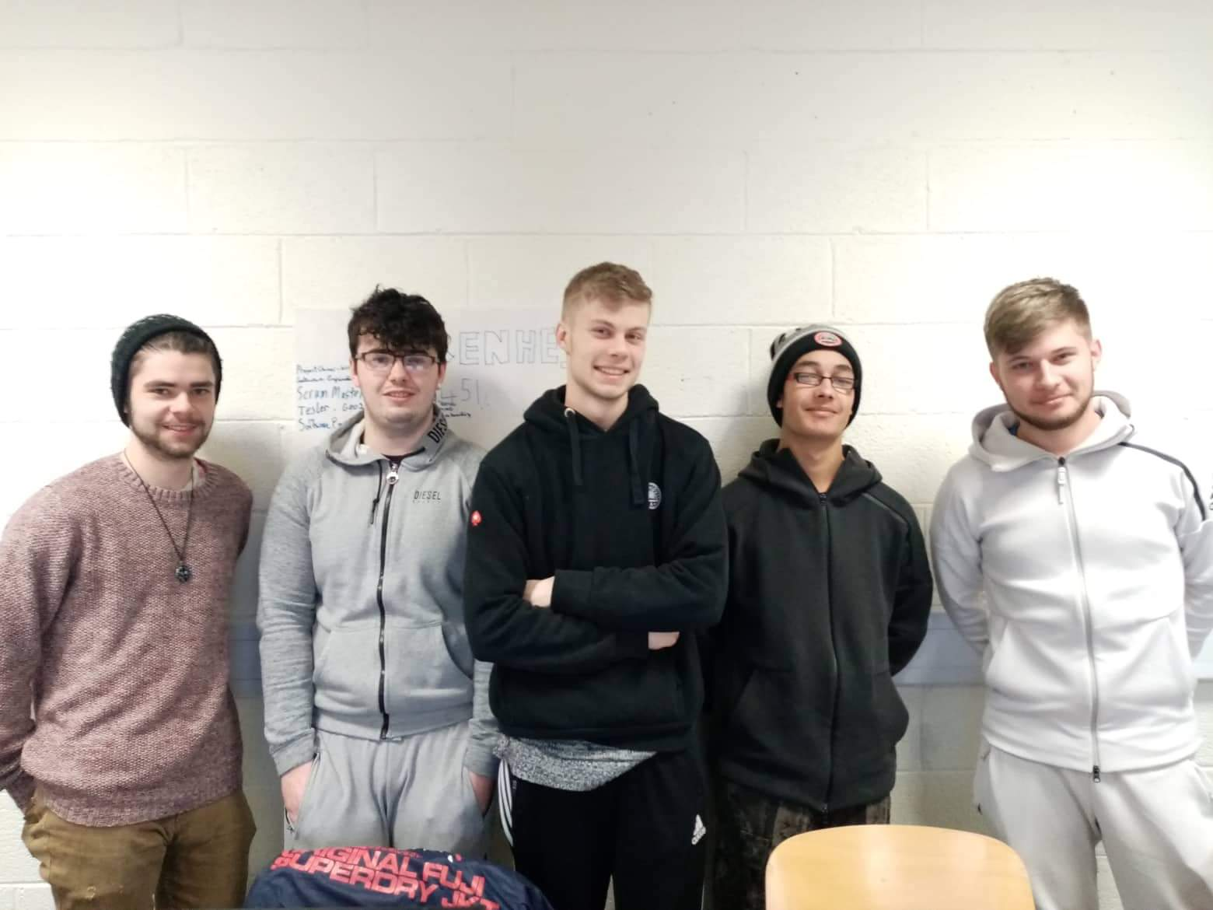

|  |  |
| --- | --- |
| Fahrenheit 451  *Wednesday 22nd of January 2020* | **MEMBERS**  Oisin Carrig – Software Engineer  Mark Considine – Tester  Pavel Antonov – Scrum Master  Connor Carney – Product Owner  Oskar Ciebien – Software Engineer  **GitHub page** <https://github.com/Pasha-Akito/Fahrenheit> |

